**Instructions for Preparation of Extended Abstract for HFSS 2023**

First A. Author 1, Second B. Author 2, Third C. Author 3

1 Institution, authorname1@domain1

2 Institution, authorname2@domain2

3 Institution, authorname3@domain3

*Keywords: Instructions, Abstract Preparation, Contact Information, Slender Structures (max. five)*

1. Introduction

These instructions are prepared as a template for authors submitting a two-page extended abstract for HFSS 2023. The text should be written in English, outline the main motivation behind the presented work, methodological features, principal results and the most important conclusions, and include the key references. The work contained in the extended abstract must be presented at the conference by a registered participant.

1. Submission and important dates

The extended abstract should be submitted electronically in the Portable Document Format (PDF) by following the procedure explained on the conference web page (<https://hfss.uniri.hr>), where the templates are available in MS Word and LaTeX formats. The extended abstract deadline submission is set to **1 March 2023**. The authors will be notified about acceptance of the extended abstract before 1 May 2023, when they will have the possibility to replace it by an updated version. Final acceptance of the extended abstracts is conditional on receiving payment of the presenting author's conference fees before 1 September 2023.

1. Layout

The extended abstract should be prepared using Times New Roman font. The title of the extended abstract should be written in boldface using 14pt font size, while the authors' names and affiliations should be written in lightface using 11pt font size. An italic font size of 11pt should be used for keywords. The body text should be written in lightface with single spacing using 11pt font size in a single column. The presenting author's name should be underlined.

1. Section heading

Section headings should be left-justified and written in boldface using 11pt font size. All text should be justified aligned, apart from the title, authors' names and affiliations, as well as table titles and figure captions, which should be centred.

* 1. Subsection heading

Subection headings (subheadings) should be left-justified and also written in boldface using 11pt font size. A paragraph should end with a space after the paragraph and the text in a new paragraph should start without an indentation.

1. References, figures, tables and equations

References should be numbered in the main text using Arabic numbers in brackets [1] as they appear in the text and listed at the end of the extended abstract, under the heading References. The bibliographic style presented at the end of these instructions [1-3] should be used.

All pictures and tables should be centred and referred to within the text (Figure 1). A font size of 10pt should be used for the table titles and figure captions (Table 1). Figure captions should be centred and positioned below the figure, while table titles should be centred above the table, as shown in Figure 1 and Table 1. When preparing the figures, please bear in mind that the extended abstract will be reduced by cca 16% and printed in black and white for the purposes of reproduction in the Book of Extended Abstracts.

**Table 1.** Table title (10pt).

|  |  |  |
| --- | --- | --- |
| **11 pt** | **14 pt** | **10pt** |
| Body text  Authors’ names and affiliations  *Keywords (italic)* | Title | References  Table titles  Figure captions |

Equations referred to in the text should be numbered consecutively using right-flushed Arabic numbers in parentheses as shown below

$\left[\begin{matrix}M & Φ_{x}^{T} \\ Φ_{x} & 0\end{matrix}\right]\left[\begin{matrix}\ddot{x} \\ λ\end{matrix}\right]=\left[\begin{matrix}R \\ -{\dot{Φ}}_{x}\dot{x}\end{matrix}\right]$, (1)

$Γ=Λ^{T}r^{'}-E_{1}$. (2)

All symbols in Equations (1) and (2) should be explained in the text. The matrices and vectors should be printed using boldface upright symbols, the scalars are written as lightface italic, while the numbers are written as lightface upright.

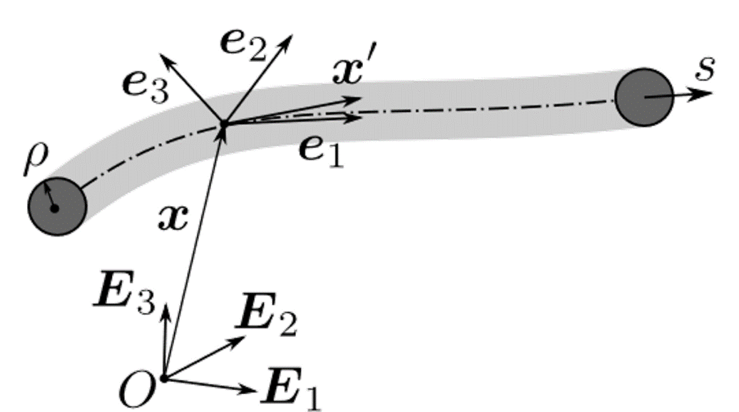

**Figure 1.** Figure caption (10pt).

1. Conclusions

For any questions, feel free to contact our Local Organising Committee by e-mail on [hfss-info@uniri.hr.](mailto:hfss-info@uniri.hr) Please submit your extended abstract before **1 March 2023** and you will receive acceptance notification before **1 May 2023**. Final acceptance is conditional on receiving payment of the presenting author's conference fees before **1 September 2023**.

Acknowledgements

This project has received funding from the European Union's Horizon 2020 research and innovation programme under the Marie Skłodowska-Curie grant agreement No 860124 ... or similar.

References

[1] S. Author, T. Author, U. Author. *Paper Title*, Journal, Volume (Year) firstpage-lastpage

[2] S. Author. *Title*, Conference, Editor, page1-pageN, Year.

[3] S. Author, T. Author. *Book Title*, Publisher, Place of Publication, Year.