**Instructions for Preparation of Extended Abstract for HFSS 2025**

First A. Author 1, Second B. Author 2, Third C. Author 3

1 Institution, authorname1@domain1

2 Institution, authorname2@domain2

3 Institution, authorname3@domain3

*Keywords: Instructions, Abstract Preparation, Contact Information, Slender Structures (max. five)*

1. Introduction

These instructions are prepared as a template for authors submitting a two-page extended abstract for HFSS 2025. The text should be written in English, outline the main motivation behind the presented work, methodological features, principal results and the most important conclusions, and include the key references. The work contained in the extended abstract must be presented at the conference by a registered participant.

1. Submission and important dates

The extended abstract should be submitted electronically in the Portable Document Format (PDF) by following the procedure explained on the conference web page (<https://hfss.uniri.hr>), where the templates are available in MS Word and LaTeX formats. Please refer to the conference website for the date of submission deadline and acceptance notification. After notification about acceptance, authors will have the possibility to replace the extended abstract by an updated version. Final acceptance of the extended abstracts is conditional on receiving payment of the presenting author's conference fees before 1 September 2025.

1. Layout

The extended abstract should be prepared using Times New Roman font. The title of the extended abstract should be written in boldface using 14pt font size, while the authors' names and affiliations should be written in lightface using 11pt font size. An italic font size of 11pt should be used for keywords. The body text should be written in lightface with single spacing using 11pt font size in a single column. The presenting author's name should be underlined.

1. Section heading

Section headings should be left-justified and written in boldface using 11pt font size. All text should be justified aligned, apart from the title, authors' names and affiliations, as well as table titles and figure captions, which should be centred.

* 1. Subsection heading

Subsection headings (subheadings) should be left-justified and also written in boldface using 11pt font size. A paragraph should end with a space after the paragraph and the text in a new paragraph should start without an indentation.

1. References, figures, tables and equations

References should be numbered in the main text using Arabic numbers in brackets [1] as they appear in the text and listed at the end of the extended abstract, under the heading References. The bibliographic style presented at the end of these instructions [1-3] should be used.

All pictures and tables should be centred and referred to within the text (Figure 1). A font size of 10pt should be used for the table titles and figure captions (Table 1). Figure captions should be centred and positioned below the figure, while table titles should be centred above the table, as shown in Figure 1 and Table 1. When preparing the figures, please bear in mind that the extended abstract will be reduced by cca 16% and may be printed in black and white for the purposes of reproduction in the Book of Extended Abstracts.

**Table 1.** Table title (10pt).

|  |  |  |
| --- | --- | --- |
| **11 pt** | **14 pt** | **10pt** |
| Body text  Authors’ names and affiliations  *Keywords (italic)* | Title | References  Table titles  Figure captions |

Equations referred to in the text should be numbered consecutively using right-flushed Arabic numbers in parentheses as shown below

$\left[\begin{matrix}M & Φ_{x}^{T} \\ Φ_{x} & 0\end{matrix}\right]\left[\begin{matrix}\ddot{x} \\ λ\end{matrix}\right]=\left[\begin{matrix}R \\ -{\dot{Φ}}_{x}\dot{x}\end{matrix}\right]$, (1)

$Γ=Λ^{T}r^{'}-E_{1}$. (2)

All symbols in Equations (1) and (2) should be explained in the text. The matrices and vectors should be printed using boldface upright symbols, the scalars are written as lightface italic, while the numbers are written as lightface upright.

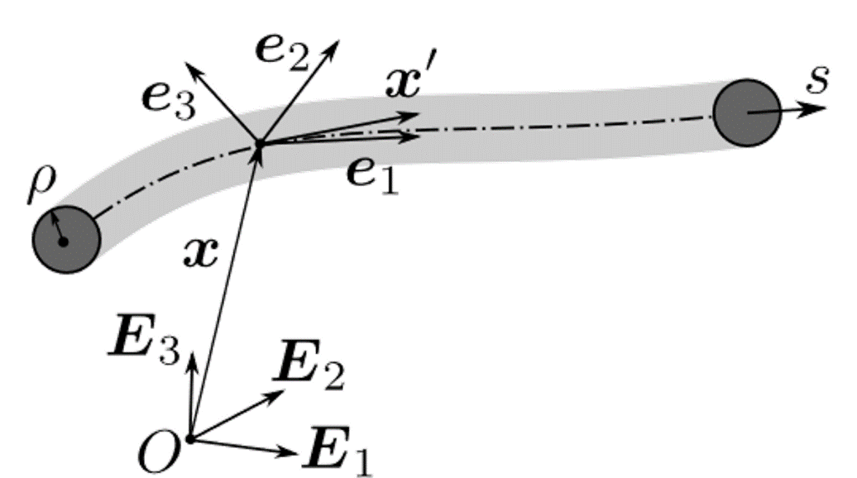

**Figure 1.** Figure caption (10pt).

1. Conclusions

For any questions, feel free to contact our Local Organising Committee by e-mail on [hfss-info@itwm.fraunhofer.de.](mailto:hfss-info@itwm.fraunhofer.de.)

Acknowledgements

This project has received funding from ...

References

[1] S. Author, T. Author, U. Author. *Paper Title*, Journal, Volume (Year) firstpage-lastpage

[2] S. Author. *Title*, Conference, Editor, page1-pageN, Year.

[3] S. Author, T. Author. *Book Title*, Publisher, Place of Publication, Year.